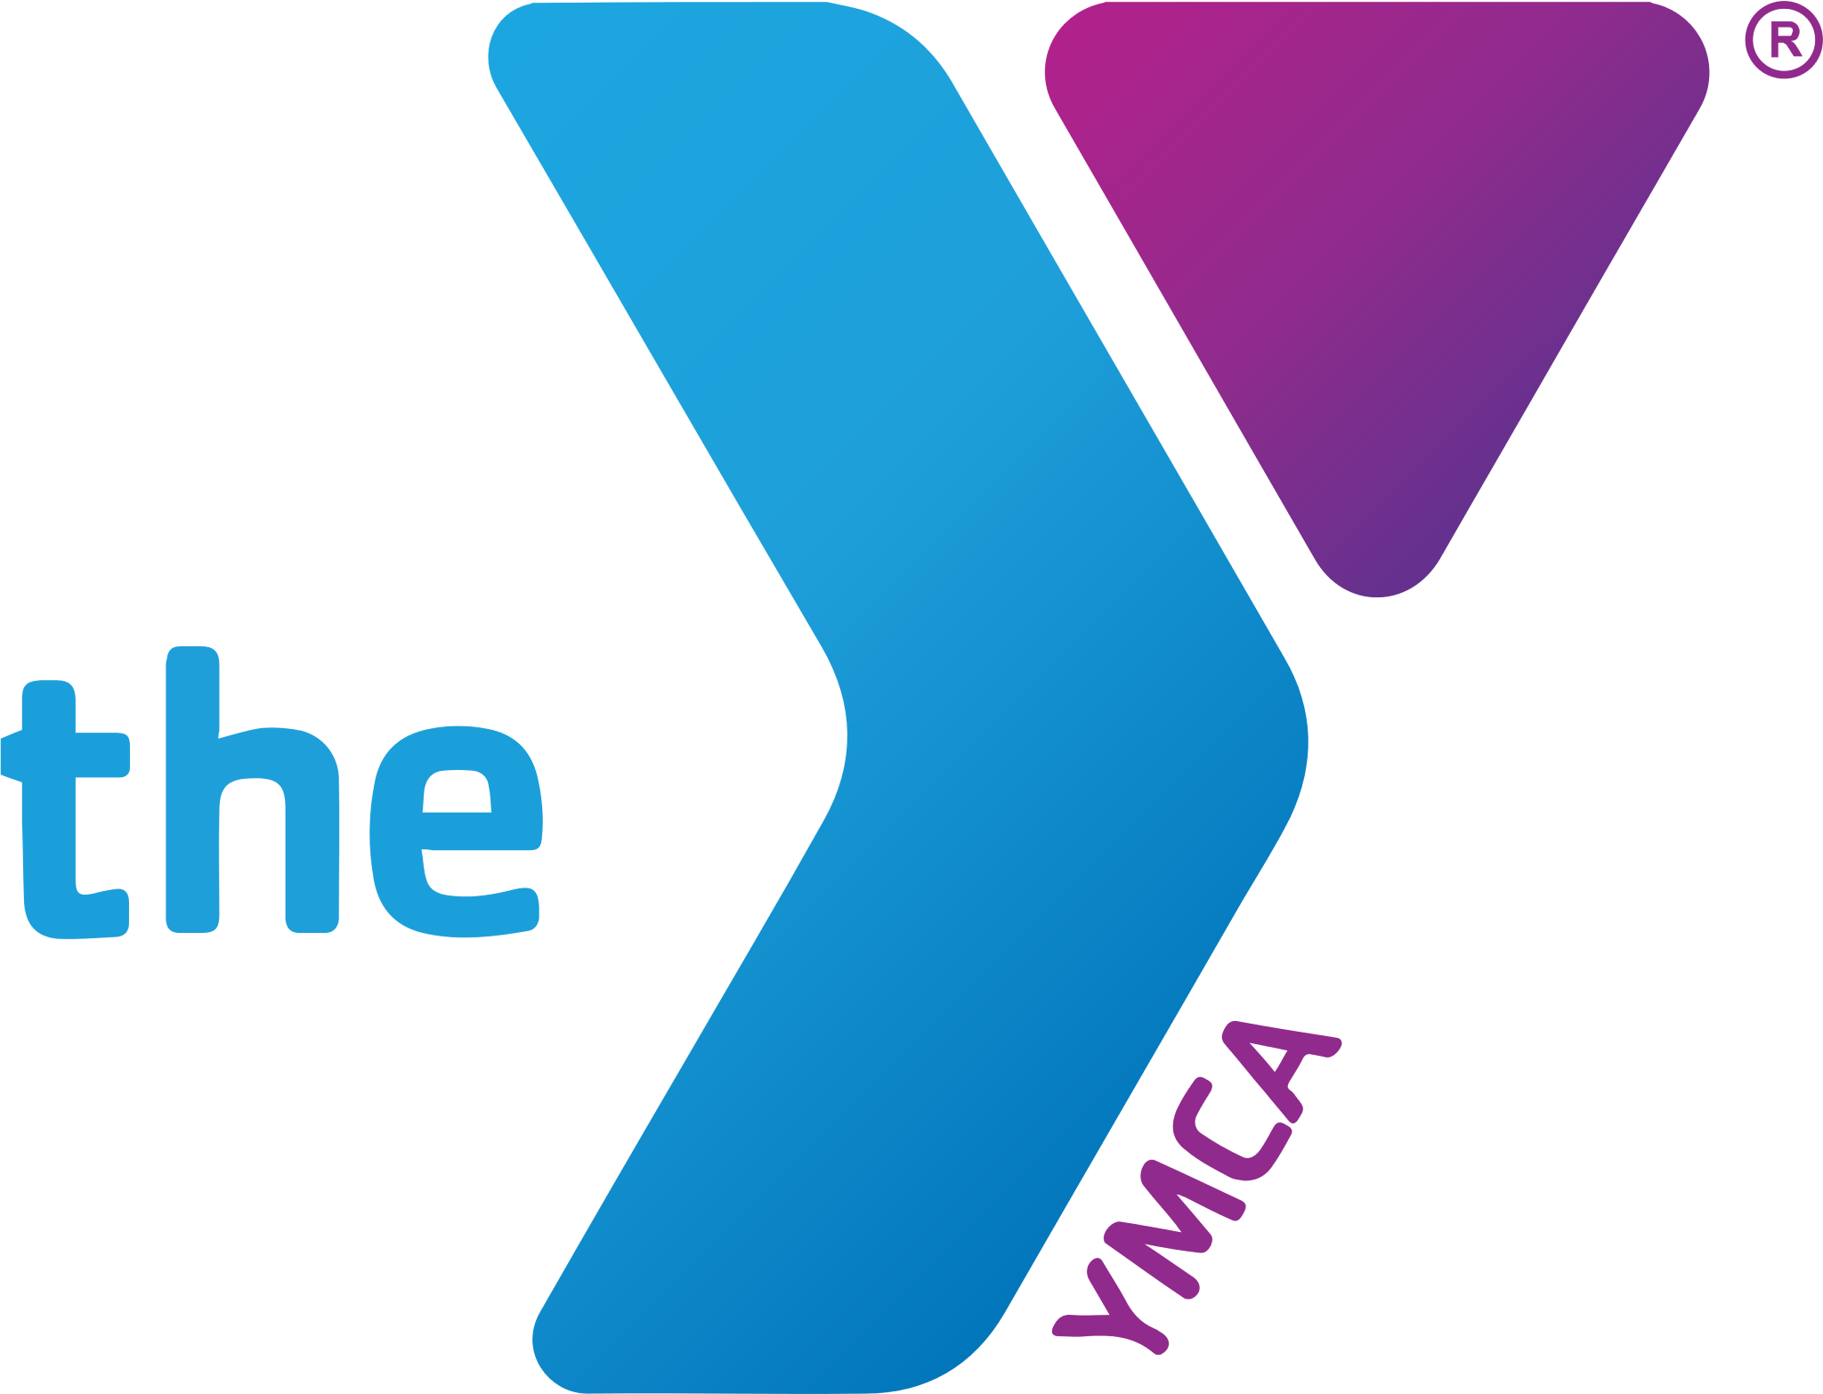 YMCA Lifeguard Certification Course

January 2026 • Brad Akins YMCA – Winder, GA
50 Brad Akins Drive • Winder, GA 30680
Cost: $125

Course Schedule:
Date | Day | Time
Jan 16 | Friday | 6:30–8:30 PM
Jan 17 | Saturday | 8:00 AM-5:00 PM
Jan 18 | Sunday | 1:00 PM–5:00 PM
Jan 23 | Friday | 6:30 PM–8:30 PM
Jan 24 | Saturday | 8:00 AM–5:00 PM
Jan 25 | Sunday | 1:00 PM–5:00 PM
The YMCA Lifeguard V7 course prepares participants to serve as professional lifeguards and rescuers. Certifications earned through ASHI:
- Basic Life Support (BLS)
- Adult & Pediatric First Aid
- Emergency Use of Medical Oxygen
Topics include accident prevention, scanning and guarding techniques, emergency systems, rescue skills, spinal injury management, legal responsibilities, pool maintenance, and job-readiness.
How to Enroll:
- Submit Form & Payment in person at the welcome desk at The Brad Akins YMCA
- Check your email. You will be sent the following:
  - 3 Online courses and links (8–10 hrs)
  - 1 Enrollment link for in-person class - Online work must be completed before class enrollment - After all e-learnings are complete, you must register for the class using the appropriate link provided by the instructor.
Deadlines:
- Form and payment submission by January 14
- Completion of online coursework by January 15
- Online registration for the in-person class by January 15
- (You will not be able to register unless all pre-work is done)
- Attend Class & Swim Test on Day 1 January 16
  - No refunds. Be prepared and confident!

Physical Competency Swim
Students must be at least 15 years old by the first day and pass all phases to continue:
Phase 1 – Continuous Swim (350 yards total):
- 100 yards front crawl
- 100 yards breaststroke
- 50 yards front crawl with head up
- 50 yards breaststroke with head up
- 50 yards elementary backstroke kick (hands on chest/stomach)
Phase 2 – Tread Water:
- 2 minutes without using arms
Phase 3 – Combined Skills Event (no goggles):
- Start in water and sprint ~20 yards
- Surface dive in 6 ft of water
- Retrieve object from bottom
- Tread water 1 minute (legs only) holding the object
- Swim the rest of the pool on your back holding the object
- Exit pool, and immediately perform 1 minute of compressions on an adult manikin

Student Checklist
- Submit form & payment by January 14
- Complete online coursework (8–10 hrs) via Instructor’s email and link
- Register for in-person class via instructor’s same link by January 15 (Scroll to the bottom of the page to register-click all the way through each page until you have received confirmation that you are registered)
- Be prepared for physical swim test on first day January 16
- Bring swim gear, towel, and a positive attitude!
Questions: Contact Tina Henderson at TinaH@gapiedmontymca.org

Lifeguard Course Registration Form

Please write legible
Student Name ___________________________________________________
Student Email ___________________________________________________
Address________________________________________________________
City___________________Zip___________
Student Phone________________________
DOB__________________ Age_____
Must be 15 years of age by the first day of class
Emergency Contact Name____________________________________________
Emergency Contact Phone___________________________________________
Any physical concerns that we should be aware of? ______________________________________________________________________________________________________________________________________________________________________________________________________

If student is under 18 years of age:
Parent Signature _________________________________________________
Parent Cell Phone: ________________________________________________
Parent Email:____________________________________________________

YMCA OF GEORGIA’S PIEDMONT PARTICIPANT WAIVER
As a participant in programs offered through the YMCA of Georgia’s Piedmont for either myself or my child, the undersigned acknowledges and agrees to the following:
- The YMCA is a Christian organization, and my child and I are expected to conduct ourselves in accordance with the teachings of Jesus Christ.
- I give my permission to the YMCA of Georgia’s Piedmont for the use of photos and slides that may be taken of my child or of myself and to use, without limitation or obligation, photographs, film footage, or tape recordings which may include either my image or voice or the image and voice of my child for purposes of promoting or interpreting YMCA programs.
- I acknowledge that the YMCA of Georgia’s Piedmont is not responsible for any injury or illness that may occur to me or my child during participation in its activities or programs. This includes the use of any equipment, exercises, or participation in events held on YMCA property or in conjunction with activities sponsored by the YMCA of Georgia’s Piedmont.
In consideration of the privilege of participation at the YMCA, I hereby voluntarily release and discharge the YMCA of Georgia’s Piedmont, its officers, directors, employees, agents, and/or servants from any and all claims, including injury, illness, death, loss, or damage, which I or my child may suffer as a result of participation in these activities. I acknowledge that fees paid to the YMCA of Georgia’s Piedmont to participate in activities do not provide accident or medical insurance, and I completely release the YMCA of Georgia’s Piedmont, along with its officers, directors, and employees, from any claims or liability.
Furthermore, I acknowledge that athletic activities involve the risk of head injuries and concussions. The YMCA of Georgia’s Piedmont is committed to promoting concussion awareness and athlete protection. I understand and agree:
  - Participants should report any signs or symptoms of concussion immediately to YMCA staff or coaches.
  - Participants suspected of having a concussion will be promptly removed from play and will not be allowed to return until cleared by a licensed health care provider.
  - The YMCA encourages all families to educate themselves and their children about concussion symptoms and safe return-to-play practices.
  - Possible symptoms of a concussion may include:
dizziness or balance problems, headache, confusion or disorientation, sensitivity to light or noise, nausea or vomiting, blurred vision, difficulty concentrating, memory problems, feeling sluggish or groggy, and mood or behavior changes.
Participation indicates understanding and acceptance of these safety measures.
- I understand the YMCA of Georgia’s Piedmont is not responsible for personal property lost or stolen while members and/or program participants are using YMCA facilities, participating in YMCA activities, or on YMCA premises.
- While the YMCA of Georgia’s Piedmont will make every attempt to provide reasonable accommodation for mentally and physically challenged children and adults, the YMCA will not accept children or adults that are (a) of danger to themselves, (b) of danger to others, or (c) a disruption to the normal activities making it unreasonably difficult for other children or adults to enjoy YMCA programs and activities. Any of the above reasons will be grounds for dismissal from YMCA programs and activities. We strongly recommend that you discuss with YMCA of Georgia’s Piedmont staff any special conditions or circumstances involving your child or an adult member in your household. We request that you do this prior to registration so that we can advise you as to whether we can make any reasonable accommodation for your child or adult household member.
Transportation Release of Liability
In the event that transportation is provided, coordinated, or arranged by the YMCA of Georgia’s Piedmont for myself or my child to or from YMCA-sponsored activities or events, I understand and agree that the YMCA assumes no responsibility or liability for any accident, injury, illness, loss, or damage that may occur during such transportation. I hereby release and discharge the YMCA of Georgia’s Piedmont, its officers, directors, employees, agents, and volunteers from any and all claims or liability arising out of or in connection with transportation services provided in association with YMCA programs or events.
Refund Policy
Refunds or credits are available only if requested before the program begins. If a request is made prior to the first day of the program, you will have two options: (1) receive immediate system credit for the full amount or (2) receive a refund minus a 25% administration fee.
Our pools close if there is thunder or lightning within a 10 mile radius.If we exceed the allotted number of make-up days due to multiple cancellations, No refunds will be given.

ACCEPTANCE
I have read and willingly signed this waiver, release of liability, and indemnification agreement, and I confirm that no verbal promises or statements have been made other than what is written in this document. I also accept the Conditions of Membership as well as the conditions imposed upon participants, both youth and adult, in activities and programs provided by the YMCA of Georgia’s Piedmont.

Participant’s Name (Printed): _____________________________________________________
Participant’s Signature: __________________________________________________________
Date Signed: _______________________________
If the participant is a minor, Parent’s/Guardian’s Name (Printed):
_____________________________________________________________________________
Parent’s/Guardian’s Signature: ____________________________________________________
Date Signed: ________________________________

