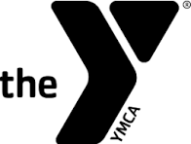

Walton County YMCA Fitness Games
Sponsorship Form

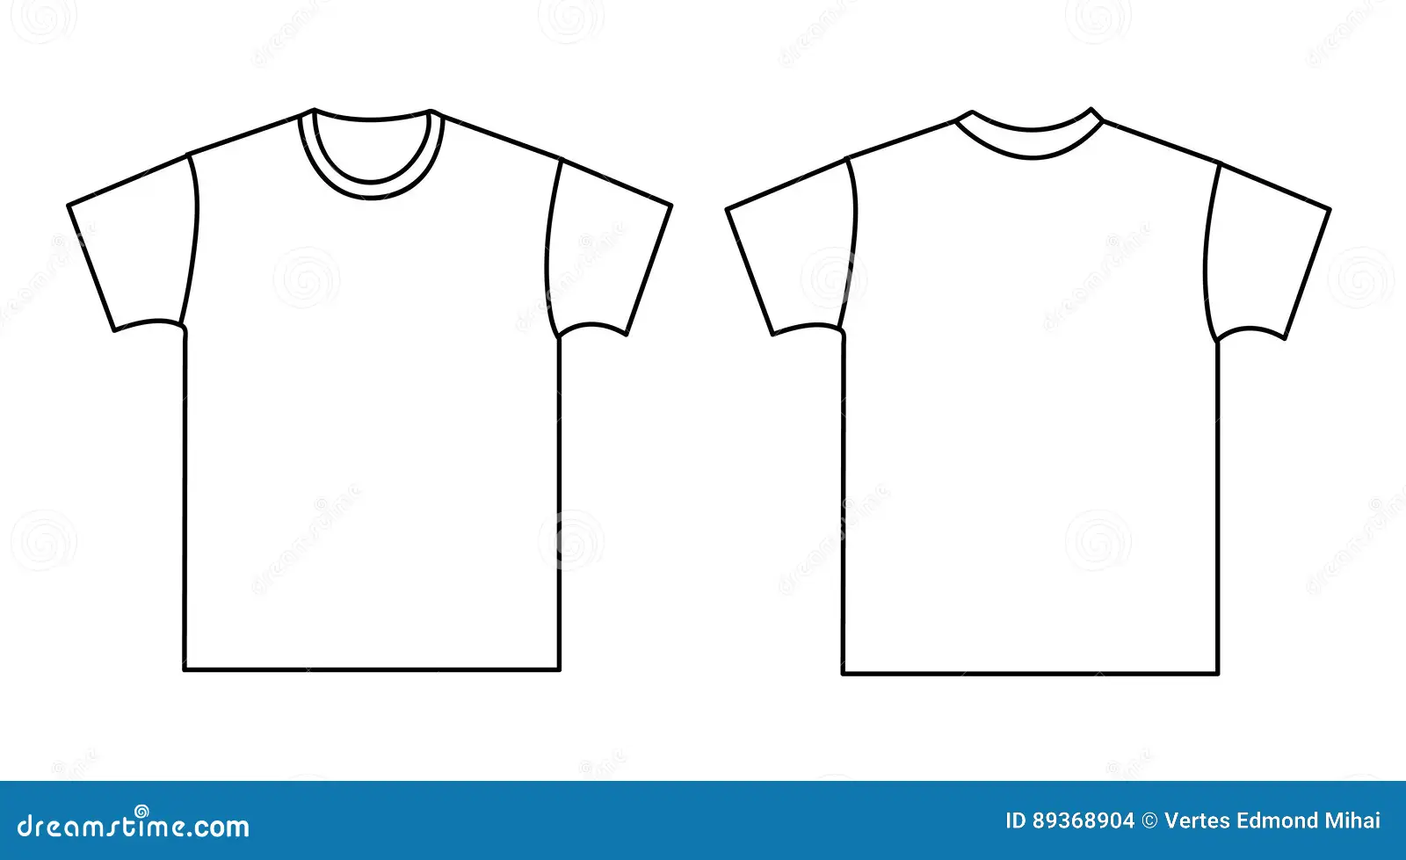
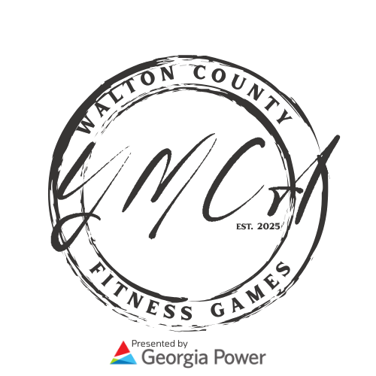

Front
Sponsor Information
Select desired sponsorship level

- Event Sponsor $500: 8 Opportunities
- Community Sponsor $250: 10 Opportunities

Payment Method:
☐ Cash ☐ Check ☐ Credit Card

Company Name:___________________________
Contact Name: ____________________________
Address:_________________________________
_________________________________

2026 Sponsors
Back

Email: _____________________________
Phone: ______________________________
Complimentary tee shirt size: XS, S, M, L, XL, 2X, 3X (circle)

Your logo will be placed in a 3" box for Event Sponsors and a 1” box for Community Sponsors on the back of the event shirt, positioned according to where the digital artist feels it fits best with the overall design. Please send a high-resolution JPG, EPS, or PNG file with a transparent background to kellyr@gapiedmontymca.org.

If you have any questions please email or call Kelly Range at kellyr@gapiedmontymca.org or 770-267-9622.

Please mail checks to
1101 Double Springs Church Road
Monroe, GA 30656

