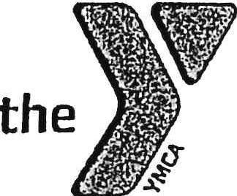
Walton County YMCA Games
Event Volunteer Application

Thank you for your interest in the YMCA. As a YMCA volunteer, your time and talent can go a long way. No matter how you help, you'll make a big difference as you work with others to create a feeling of connectedness in your community.

Name: _____________________________________ Sex: M / F Birthday:__________
Address: ______________________________________________________________
Phone number: _________________________________________________________
Email address: _________________________________________________________
Occupation, hobbies, areas of interest: ______________________________________
______________________________________________________________________
Why do you want to volunteer at the Walton County YMCA? ______________________
____________________________________________________________________________________________________________________________________________
______________________________________________________________________

Desired Volunteer Areas:
□ Hydration Station | □ Station Master
□ Traffic Control | □ Set Up
□ Team Coach | □ Clean Up
(Job descriptions on back)

The undersigned acknowledges and agrees to the following:
“The YMCA of Georgia’s Piedmont is a Christian organization and that I am expected to conduct myself in accordance with the teachings of Jesus Christ.”

Applicant Signature: ______________________________________ Date:__________
Guardian Signature (if under 18): ______________________________ Date:__________

Walton County YMCA Games
Job Descriptions

Hydration Station: (need 2) Keeps participants energized and safe.
Set up and manage the water/hydration area, Refill water cups and bottles as needed, Encourage participants to stay hydrated, Keep the station clean and stocked
Best for: Friendly, attentive people who like helping others

Traffic Controller: (need 2) Help with flow and safety
Assist with parking, Direct participants and spectators to correct areas, Help manage foot traffic between stations, Ensure walkways remain clear and safe, Communicate with event leaders if issues arise
Best for: Confident communicators who can stay calm and alert

Team Coach: (need 16) Motivate and guide a group
Lead and encourage a team throughout the event, Keep the team on schedule and engaged, Promote sportsmanship and positivity, Maintains the team score card
Best for: Energetic leaders who enjoy motivating others

Station Master: (need 8) Run an activity station
Set up and manage a specific activity station, Explain rules and instructions clearly, Track participation at the station, Ensure equipment is used safely, Scores each team on reps, Communicates scores to Team Coach
Best for: Organized individuals who can multitask

Set Up Crew: (need 2) Prepare the event space
Set up tables, chairs, signage, and equipment, Help arrange stations according to the event layout, Assist with last-minute adjustments before the event starts
Best for: Early birds who don’t mind physical activity

Clean Up Crew: (need 3) Wrap up the event
Break down stations and equipment, Collect trash and recycling, Return supplies to storage areas, Leave the venue clean and organized
Best for: Dependable helpers who can stay after the even

