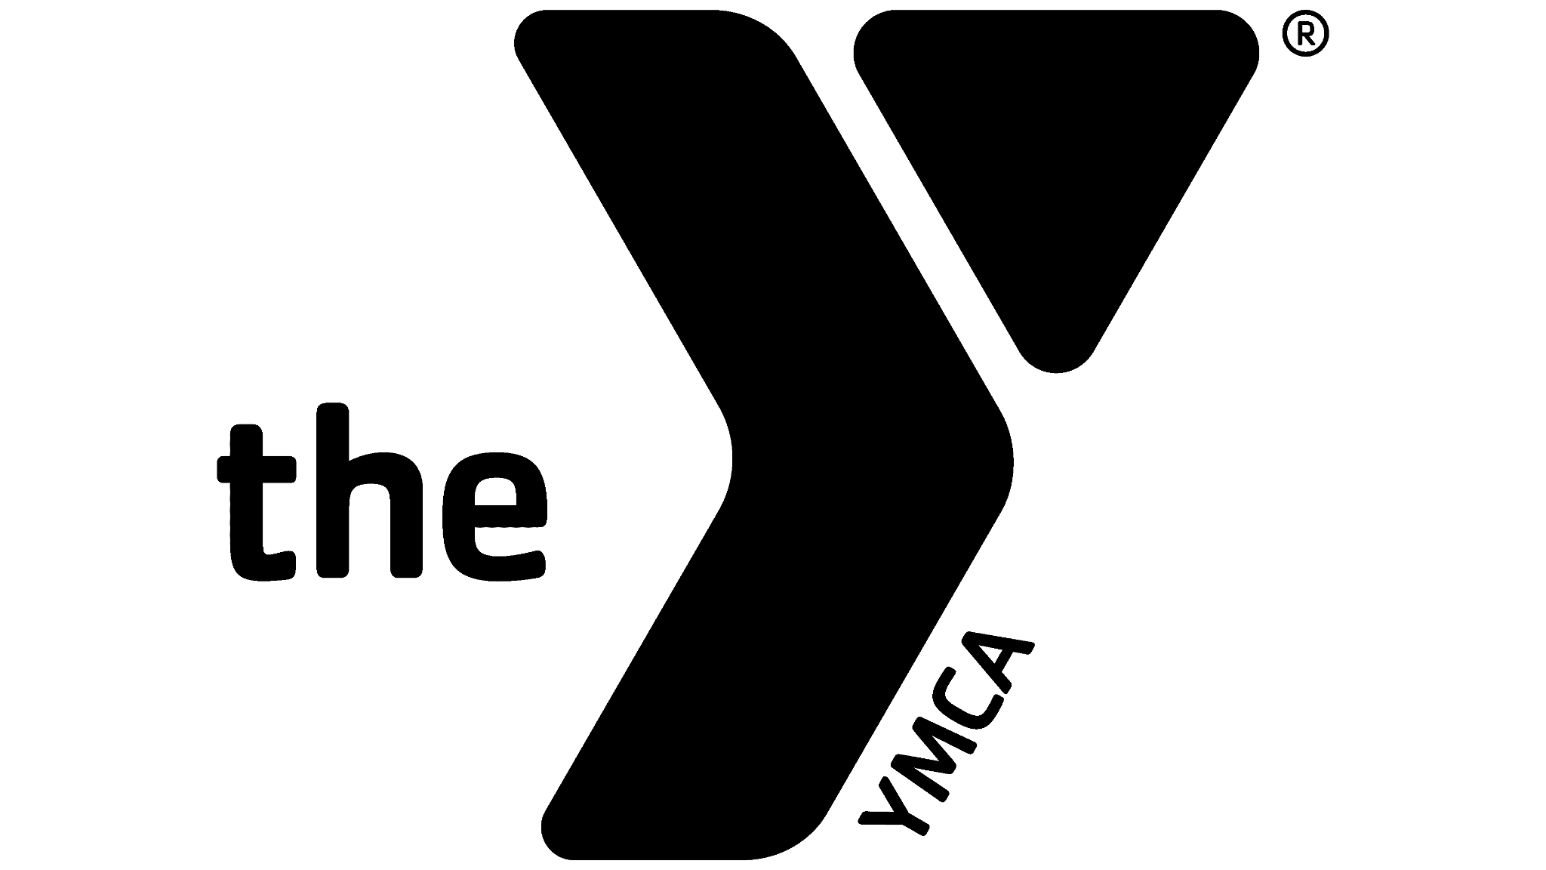Walton County YMCA Games 2026
This event is a fundraiser for our Annual Campaign. The YMCA Annual Support Campaign raises funds to ensure everyone has access to YMCA programs, regardless of their ability to pay. It supports youth programs, family services, wellness initiatives, and community outreach. The campaign benefits low-income families, children, seniors, and individuals facing hardship, helping to build a stronger, healthier, and more inclusive community.
Team Structure

- Teams of 3
- Men’s division/Women’s division/Co-ed division
- Minimum age: 18
- Waivers required for all participants.

Competition Structure

Event 1: Tactical Swim
Type: Pair
Focus: Endurance
For Time:
- 2 team members swim a combined 500 yards.
- Strategy: Split the distance however you choose. Only one person may work at a time. Team members must start in the water.
- Score = Total time to complete 500 yards.

Event 2: Trail Relay Run
Type: Team
Focus: Endurance / Team Unity
For Time:
- Each team member completes 1 lap of the outdoor trail. Approximately 1 mile total (.35 per person).
- Relay style: 1 runner at a time
- Score = Total team time (all 3 laps combined).

Event 3: Tactical Row + Push-Up Bonus
Type: Individual + Team
Focus: Endurance / Strength / Team Unity
Row For Distance:
- Women: 1500m
- Men: 2000m
While rowing:
- Remaining teammates do hand release push-ups for max reps. 1 person works at a time.
- For every push-up rep, subtract 1 second from total row time.
- Score = Adjusted row time (Row time - Push-up reps).

Event 4: Max Deadlift
Type: Pair
Focus: Strength
Time Cap: 10 minutes
Goal:
- 2 athletes build to a 1-rep max deadlift
- Each lifter gets 3 attempts
- Score = Combined max lift from both athletes

Event 5: Clean & Press Burnout
Type: Individual + Team
Focus: Strength / Team Unity
For Max Reps in 90 Seconds:
- 1 athlete completes as many Clean & Press as possible. Plates must tap down each rep and elbows must lock out at top.
  - Rx Weights: Men 100lbs, Women 50lbs
- Other teammates must hold a Wall Sit for the rep count to count. Crease of hip must line with knee joint for 90 degree angle. Hands must be by sides.
  - 5-rep penalty if wall sit is broken
- Score = Total reps - penalties

Event 6: Burpee Team Gauntlet
Type: Team
Focus: Endurance / Team Unity
For Max Reps in 4 Minutes:
- Team performs as many burpees as possible. One person works at a time. The chest must touch the ground at the bottom of the burpee and toes must leave the ground at the top. Both feet must move in tandem during the jump back and jump in.
- Everyone must complete at least one rep.
- Reps can be divided however the team chooses.

- Score = Total team burpee count

Event 7: Team Tire Flip
Type: Team
Focus: Strength / Team Unity
For Time:
- Flip the tire down and back (distance tbd)
- Teams strategize who flips and how
- All members can participate, but not all are required
- Score = Total time to complete the distance

Event 8: AMRAP + Farmer’s Carry Relay
Type: Team (2 + 1 rotation)
Focus: Strength / Endurance / Team Unity
10-Minute AMRAP
- 2 athletes alternate full rounds (leapfrog style):
• 70 Single Unders
• 25 Air Squats
• 10 Single arm Dumbbell Press. You can use both arms in one set. Dumbbell goes shoulder to overhead.
  - Rx Weight: Men 45lbs, Women 25lbs
- 3rd athlete: Completes 5 down-and-back laps of Farmer’s Carry
  - Rx Weight: Men 2 x 45lbs plates, Women 2 x 25lbs plates
AMRAP score only counts if the farmer’s carry is completed within 10 minutes
Score = Total dumbbell reps completed
Scoring System
Award points per event based on placement.
- 1st awarded 10pts
- 2nd awarded 8pts
- 3rd awarded 6pts
- 4th awarded 4pts
- 5th awarded 2pts
- All other teams 1pt.
Tie breaker: Use cumulative team time from event 2: Trail Relay Run

Prizes
1st place: Team trophy, free entry into next years event, local wellness package, swag bag with local sponsor items, bragging rights
2nd place: Local wellness package, medals, swag bag with local sponsor items
3rd place: Swag bag with local sponsor items

Fundraising
- Team entry fee: $125
- Sponsors:
- Gold $1000: Presenting Sponsor, logo on front of t shirt, digital recognition
- Silver $500: Event Sponsor, larger logo on back of shirt, company name at one event table
- Bronze $250: Logo on t shirt and digital recognition

Marketing and Community Engagement
- Invite local gyms, businesses, county offices, etc.
- Corporate Wellness Challenge: Offer companies an incentive to sponsor a team.
- Local businesses donate items like food, drinks, lunch, gift cards for winners, etc.

