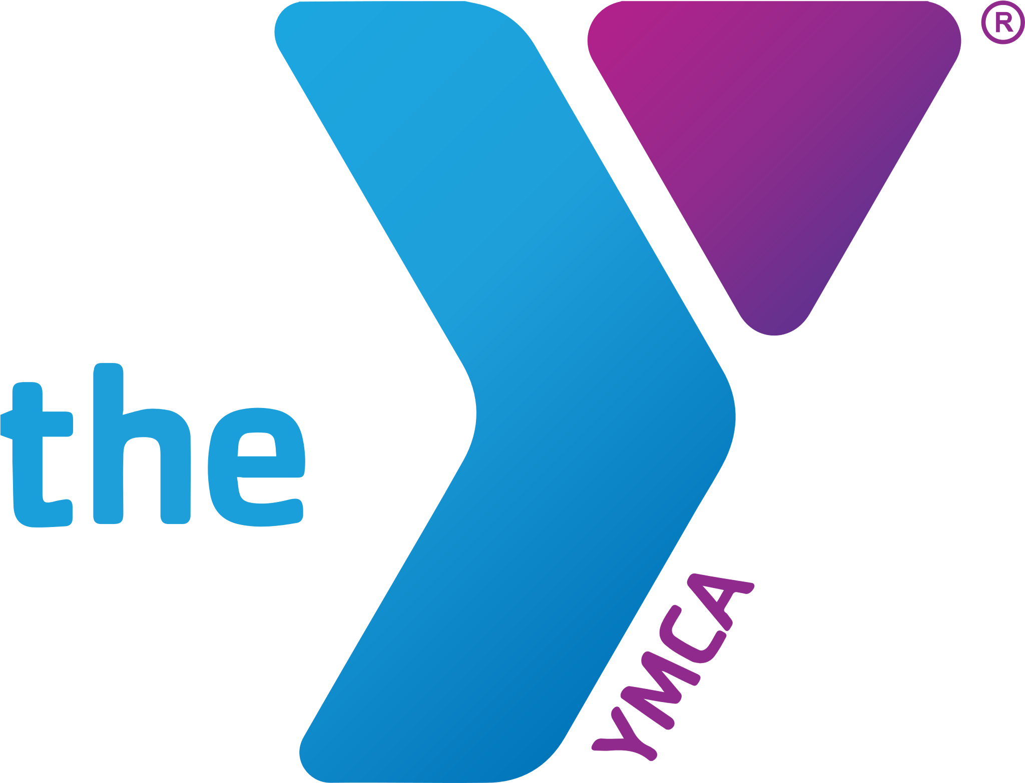**SPECIAL OLYMPICS SWIM TEAM**

Ages 8+

To be eligible to participate in our Special Olympics program, the swimmer must be identified by an agency or professional as having one of the following conditions: intellectual disabilities, cognitive delays as measured by formal assessment, or significant learning or vocational problems due to cognitive delay that require or have required specifically designed instruction.

This program is not swim lessons. During the practice coaches may not be in the water with participants. There are certain abilities a potential swimmer must know and complete before joining our program. A list has been provided below to help ensure your swimmer meets the requirements to participate. Prior to completing your registration, your swimmer will be required to attend an evaluation.

**This form must be signed by a coach and shown to Y staff to register. Keep this form for your reference.**

* MUST be able to follow directions and work well with others
* Be comfortable in the deep end
* Be able to swim unassisted one length on front without touching the wall/bottom
* Be able to float or glide on back without assistance
* Be able to put their face in the water without holding their nose
* Be able to enter and exit the water without assistance

**Coach_______________________________________________**

**Our pools close when thunder or lightning is detected within a 10 mile radius**

**We will contact you using the primary phone number if we cancel practice due to inclement weather.**

Make up practices are not guaranteed.

Our team will be participating in the Summer Games. Special Olympics Georgia (SOGA) will host the 2026 State Summer Games at Emory University in May of 2026. Over 2,000 Athletes, Coaches and Unified Partners from around the State will come to Emory and University’s campus to compete in Athletics. More information can be found at [State Summer Games – Special Olympics Georgia](https://www.specialolympicsga.org/become-an-athlete/competition-schedule/state-summer-games/)

**Evaluations by appointment: Contact Tina at** [**TinaH@gapiedmontymca.org**](mailto:Tinah@gapiedmontymca.org)

**Spaces Limited**

**SOGA**

**Special Olympics Georgia**

**Members: $70.00 Non Members: $85.00**

(Scholarships available)

**4 practices per session-Choose one location**

**Wednesdays at the Walton Y in Monroe 6:00-6:45pm**

* Session 1:10/22 10/29 11/5 11/12
* Session 2: 11/19 12/3 12/10 12/17

**OR**

**Thursdays at the Brad Akins Y in Winder 6:00-6:45pm**

* Session 1: 10/23 10/30 11/6 11/13
* Session 2: 11/20 12/4 12/11 12/18

2026 practice schedule will be published November 2025

SWIMMER’S NAME **__________________________________________**

DATE OF BIRTH / / AGE MALE FEMALE .

ADDRESS___________________________________________________________

**Please provide the email that you check the most in order to receive important information. This is our most effective form of communication. Please print legibly

Primary Guardian_______________________________

Email__________________________________ Phone Number_______________

Secondary Guardian_______________________________

Email__________________________________ Phone Number_______________

YMCA MISSION: “To put Christian principles into practice through programs that build healthy spirit, mind and body for all.



YMCA OF GEORGIA’S PIEDMONT PARTICIPANT WAIVER

**Participant Waiver**

As a participant in programs offered through the YMCA of Georgia’s Piedmont for either myself or my child, the undersigned acknowledges and agrees to the following:

1. The YMCA is a Christian organization and my child and I are expected to conduct ourselves in accordance with the teachings of Jesus Christ.
2. I give my permission to the YMCA of Georgia’s Piedmont for the use of photos and slides that may be taken of my child, or of myself and to use, without limitation or obligation, photographs, film footage, or tape recordings which may include either my image or voice or the image and voice of my child for purposes of promoting or interpreting YMCA programs.
3. I understand the YMCA of Georgia’s Piedmont assumes no responsibility for injuries or illness which I or my child may sustain as a result of physical condition or resulting from participation in any athletic activities, sports programs, the use of any equipment, exercises, or other activities while on the property of or in conjunction with any activity held, coordinated or sponsored by the YMCA of Georgia’s Piedmont. In consideration of the privilege of participation at the YMCA, I hereby voluntarily release and discharge the YMCA of Georgia’s Piedmont, its officers, directors, employees, agents, and/or servants from any claims whatsoever, including for injury, illness, death, loss or damage which I or my child may suffer as a result of my/his/her participation in these activities. I understand that no accident or medical insurance is provided with these activities.I fully indemnify and hold harmless the YMCA of Georgia’s Piedmont, its officers, directors and employees from any and all claims.
4. I understand the YMCA of Georgia’s Piedmont is not responsible for personal property lost or stolen while members and/or program participants are using YMCA facilities, participating in YMCA activities, or on YMCA premises.
5. While the YMCA of Georgia’s Piedmont will make every attempt to provide reasonable accommodations for mentally and physically challenged children and adults, the YMCA will not accept children or adults that are (a) of danger to themselves, (b) of danger to others, or (c) a disruption to the normal activities making it unreasonably difficult for other children or adults to enjoy YMCA programs and activities. Any of the above reasons will be grounds for dismissal from YMCA programs and activities. We strongly recommend that you discuss with YMCA of Georgia’s Piedmont staff any special conditions or circumstances involving your child or an adult member in your household. We request that you do this PRIOR to registration so that we can advise you as to whether we can make a reasonable accommodation for your child or adult household member.

**Acceptance**

I have read and voluntarily signed this waiver and release of liability and indemnification agreement, and further agree that no oral representation, statements or inducements apart from the foregoing written agreement have been made. I also accept the Conditions of Membership as well as the conditions imposed upon participants, both youth and adult, in activities and programs provided by the YMCA of Georgia’s Piedmont.

_______________________________________________________________________

Swimmer’s Name (Print) Parent/Guardian Name (Print)

____________________________________________________________________________

Signature of Parent/Guardian Date